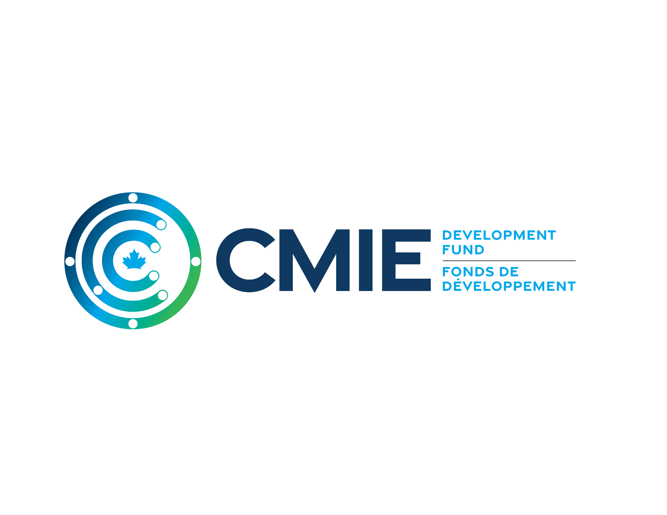

SUMMER 2025 CALL FOR PROPOSALS
FREQUENTLY ASKED QUESTIONS

Publication Date: 26 June 2025

- What kind of projects are we looking for?
  - Projects that can lead to the direct commercialization of medical isotope related technologies and products.
  - Includes diagnostics; therapeutics; equipment; and software including artificial intelligence (AI) technologies.
  - Projects that address an unmet need in the medical isotope space, have the potential to improve the lives of Canadians, consist of a team of committed collaborators, and the applicant should be able to define a path to commercialization.
  - Projects that promote cross-country collaboration, provide training and jobs to highly qualified personnel, and provide opportunity to equity seeking groups and organizations within Canada.
- What is the application process?
  - There is a two-step application process.
  - In the first step the applicants will be asked to submit a standardized non-confidential PowerPoint presentation which will include the important highlights of the project including:
    - A target product profile (TPP) that defines the minimal/ideal profile of the final marketed product.
    - Description of how the CMIE funding would advance the project towards the ultimate TPP.
    - Budget (including current and/or anticipated matched funding sources)
    - Gantt chart and description of the work
    - Description of the status of the technology that will be advanced.
    - Description of the intellectual property (IP)
    - Description of the team/management involved.
    - Competition and competitive positioning
    - Expected commercialization strategy.
  - In the second step, the application team will be asked to make a one-hour confidential presentation to the Eligible Project Selection Committee which will describe in greater detail the project.

- Why is there a two-step process for applications?
  - The first stage of the application allows for applicants to enter the application process without the need for entering a confidentiality agreement.
  - The two-step process will allow the Eligible Project Selection Committee triage and shortlist the projects.
  - The process also helps applicants familiarize themselves with a typical venture capital (VC) application process whereby the team needs to be able to distill their project into a short introductory presentation for initial vetting by potential investors.
- Who will make the project selection and funding decisions?
  - CMIE Executives will be assembling an Eligible Project Selection Committee who will be mandated to review the projects and rate the projects for funding eligibility.
  - Members of the Eligible Project Selection Committee will review potential conflicts of interests on a project-by-project basis to ensure that members can recuse themselves from the review process if a conflict is identified.
  - 1/3 of the Eligible Project Selection Committee will consist of independent reviewers. You are encouraged (but not required) to suggest industry-relevant independent reviewers for your program within your application.
- How much funding can a project receive?
  - Funding for the first call will range from $200,000 for key proof of concept studies to $500,000 for more advanced programs. As this is a competitive application process, we cannot guarantee that funding will be provided to all submissions. Additionally, there is potential that selected programs may not receive the total funding amount requested.
- How will the funds be paid?
  - The CMIEDF program is a reimbursement fund, not a disbursement fund. On a quarterly basis, recipients will submit a progress report and their eligible refundable claims. Subject to review by the CMIE and the government, funds should be forwarded to the recipient about 60-90 days after the claims are submitted subject to questions from the Minister.
- Do you have to have the matching funds secured when applying?
  - No. Recipients of Eligible Recipient Award letters will have 6 months to find the matching funding source. Recipients can use the award letter to raise the matching funds.

- How is this different from an academic grant?
  - The CMIE Development Fund (CMIEDF) is focused on funding the translation and commercialization of research or early-stage projects. The funding must be shown to advance a program towards its ultimate commercialization product, as described in a well-supported Target Product Profile
- When do projects need to be completed?
  - The program ends March 31, 2027. Suggested final claim submissions should be received by Jan 31, 2027. Claims for work conducted after March 31, 2027, will not be eligible for reimbursement.
- Does the work have to be done in Canada?
  - 90% of the work must be done in Canada.
- Do applicants need to be Canadian?
  - The fund is targeted to support Canadian companies or research at Canadian institutions.
- Can project collaborators be from outside Canada?
  - Yes, collaborators can be from outside of Canada, but are still subject to the 90% of overall work being done in Canada.
- What sources of funds are acceptable for matching?
  - A variety of funds are eligible for matching, including corporate funds, foundations, and academic sources. Other Government funding is permitted (Municipal, Provincial, Territorial, Federal) so long as the total contribution from Government sources does not exceed 75% of your project’s eligible costs/expenses.
- What kinds of expenses are eligible?
  - Eligible project costs must be reasonable and related to eligible project activities. Project costs must only include actual expenses that are incurred and traceable. Direct labour, equipment, consultants, contract research, certain travel and consumables are typically eligible costs. In-kind services are not considered an eligible expense. A full list of eligible costs is available on our website under the call for proposals tab.
- Does the CMIE ask for any Intellectual Property (IP) rights, or commercialization rights to project IP?
  - No, the IP rights will remain solely with the owners of the program. However, the Ultimate Recipients of the funding are expected to have a plan to protect and commercialize the IP developed under this program. Ultimate Recipients are required to hold the rights to their project IP for 5 years following the completion of their project.
- Does the CMIE fund follow-on projects?
  - Yes, successful projects in the first call are eligible to submit for follow-on funding in subsequent calls for submissions.
- How will projects be evaluated?
Following the above criteria, reviewers will evaluate all Eligible Project applications using the rubric below as a guide.

Location | Fit | Viability | Potential Benefits | DEI Considerations
Supports future Canadian R&D efforts | Technological focus of project | Team composition | Innovation and commercialization in Canada | Representation by underrepresented and equity-seeking groups
Overcomes a deficiency in medical isotope production | Contribution to network KPIs | Facilities and infrastructure | Involvement of SMEs and job creation
Creates investment into Canadian organizations and/or furthers Canada’s position in medical isotope R&D | Contribution to network sustainability | Risks and mitigation strategies | Benefits to healthcare and/or other sectors
 | Addresses and/or solves a problem within at least one technology focus area | Other funding sources | Development of intellectual property for technology

Qualitative Rank | Numerical Rank | Description
High | 8 | Excellent with no weaknesses identified. Reviewer has very high confidence that the strengths in this criterion will drive the project to be successful.
 | 7 | Excellent with minor weaknesses identified. Reviewer has high confidence that, with slight improvements, the strengths in this criterion could drive the project to be successful.
Medium | 6 | Very good with minor weaknesses identified. The reviewer has confidence that, with moderate improvements, the strengths in this criterion could drive the project to be successful.
 | 5 | Very good with moderate weaknesses identified. The reviewer has confidence that, with moderate improvements, the strengths in this criterion could drive the project to be successful.
 | 4 | Good with moderate weaknesses identified. The reviewer has some confidence that, with some necessary improvements, the strengths in this criterion could be enough to drive the project to be successful.
Low | 3 | Fair with moderate weaknesses identified. The reviewer is not confident that the strengths in this criterion would be enough to drive the project to be successful.
 | 2 | Poor with moderate to major weaknesses identified. The proposal does not address the aspects in this criterion, does not demonstrate strengths needed for success, and/or shows uncorrectable flaws and weaknesses. Based on this criterion, the reviewer believes this proposal is not fundable.
 | 1 | Poor with major weaknesses identified. The proposal does not address the aspects in this criterion, does not demonstrate strengths needed for success, and/or shows uncorrectable flaws and weaknesses. Based on this criterion, the reviewer believes this proposal is not fundable.

- What is a Technology Readiness Level (TRL), and how do I know what level my project is at?
  - Definitions of the nine Technology Readiness Levels are described below:
Technology Readiness Level (TRL) | Description
TRL 1—Basic principles observed and reported | Lowest level of technology readiness. Scientific research begins to be translated into applied R&D. Examples might include paper studies of a technology's basic properties.
TRL 2—Technology concept and/or application formulated Invention begins. | Once basic principles are observed, practical applications can be invented. Applications are speculative, and there may be no proof or detailed analysis to support the assumptions.
TRL 3—Analytical and experimental critical function and/or characteristic proof of concept | Active R&D is initiated. This includes analytical studies and laboratory studies to physically validate the analytical predictions of separate elements of the technology.
TRL 4—Product and/or process validation in laboratory environment | Basic technological products and/or processes are tested to establish that they will work.
TRL 5—Product and/or process validation in relevant environment | Reliability of product and/or process innovation increases significantly. The basic products and/or processes are integrated so they can be tested in a simulated environment.
TRL 6—Product and/or process prototype demonstration in a relevant environment | Prototypes are tested in a relevant environment. Represents a major step up in a technology's demonstrated readiness. Examples include testing a prototype in a simulated operational environment.
TRL 7—Product and/or process prototype demonstration in an operational environment | Prototype near or at planned operational system and requires demonstration of an actual prototype in an operational environment (e.g. in a vehicle).
TRL 8—Actual product and/or process completed and qualified through test and demonstration | Innovation has been proven to work in its final form and under expected conditions. In almost all cases, this TRL represents the end of true system development.
TRL 9—Actual product and/or process proven successful | Actual application of the product and/or process innovation in its final form or function.

